
Affiliated to Dr. A.P.J. Abdul Kalam Technical University, Lucknow

PRACTICAL FILE

PROGRAM: MBA (BUSINESS ANALYTICS)
Semester: 1

ACADEMIC YEAR: 2025–2027

SUBJECT: Business Intelligence and Power BI
SUBJECT CODE: BMBA153

SUBMITTED BY: SUBMITTED TO:
HARENDA Dr. Ajay Tripathi
SCHOLAR NO.- 2502057 (Professor)
Sign. …………………

S.NO | CONTENTS | Page No.
1 | Certificate | 3
2 | Acknowledgement | 4
3 | Objective of Experiment | 5
4 | Introduction to Power BI | 5
5 | Problem Statement | 6
6 | Dataset Description | 7
7 | Data Collection | 9
8 | Data Cleaning and Preparation | 11
9 | Data Modelling | 15
10 | Measures and Calculated Column | 17
11 | Data Visualization | 21
12 | Dashboard | 27
13 | Insights & Analysis | 29
14 | Business Interpretation | 30
15 | Conclusion | 32
16 | Limitations | 33
17 | Future Scope | 34

Certificate
This is to certify that Mr. Harendra , a student of MBA (Business Analytics), has completed the project titled “Loan Analytics using Power BI” in partial fulfilment of the requirements of the MBA program.
The project has been carried out by her under my guidance and supervision. He has demonstrated sincere effort, analytical ability, and a clear understanding of business analytics concepts, data visualization, and managerial interpretation while completing this project. His work is found to be original and satisfactory and meets the academic standards prescribed by the institute.
I wish him all the best for her future academic and professional endeavors. Name of Faculty Guide:
Designation: Department / Institution: Signature:
Date: Place:

Acknowledgement

I would like to express my sincere gratitude to my faculty guide for their valuable guidance, continuous support, and constructive feedback throughout the successful completion of this Loan Analytics Project using Power BI. Their expertise and direction were instrumental in enhancing my understanding of business analytics, data visualization, and DAX-based analysis.
I am also thankful to my institution and department for providing the necessary academic resources and a conducive learning environment that enabled the smooth execution of this project. This project has been a valuable academic experience, strengthening my analytical skills and reinforcing the practical application of data-driven decision-making using Power BI.

Project Objectives
- To analyze historical loan data in order to understand loan approval and rejection patterns across different borrower categories.
- To evaluate borrower creditworthiness using key factors such as income level, credit history, and loan amount.
- To identify and analyze patterns and trends associated with loan default.
- To visualize default risk across various customer segments using interactive dashboards in Power BI.
- To assist financial institutions in making informed, data-driven, and risk-aware loan approval decisions.



Problem Statement
Loan default is a major concern for financial institutions, as it directly impacts profitability and risk management. Existing loan evaluation processes often rely on manual analysis and static reports, which makes it difficult to identify hidden patterns related to loan approval, borrower creditworthiness, and default behavior. There is a need for an interactive analytical solution that can efficiently analyze historical loan data and provide meaningful insights to support better lending decisions.

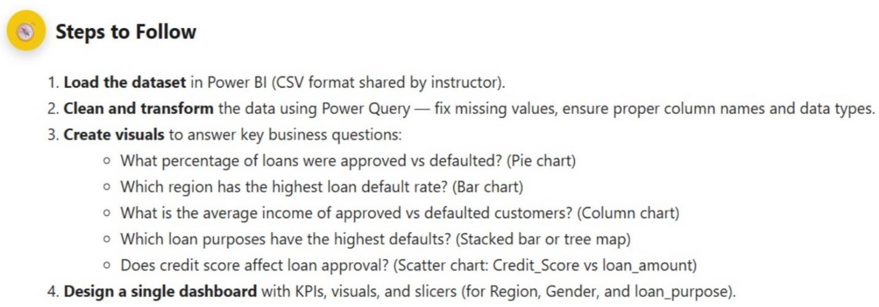

Data Description
The dataset used in this Power BI project comprises detailed records of loan applications and their corresponding outcomes. It integrates financial information, demographic attributes, and loan-specific characteristics, enabling a comprehensive analysis of borrower behavior, creditworthiness, and loan default risk.

By combining applicant income, credit score, loan amount, and interest rate with demographic details such as age, gender, and geographic region, the dataset supports multidimensional analysis. Additionally, information related to loan purpose and loan status allows for meaningful comparisons across different borrower segments. This structured dataset forms a strong foundation for building interactive and insightful Power BI dashboards aimed at supporting data- driven lending decisions.

Dataset Attributes

Financial Attributes

- Loan amount: Represents the total loan amount requested by the applicant, used to evaluate risk exposure.
- Rate of interest: Indicates the interest rate applied to the loan, often influenced by the applicant’s credit profile.
- Credit Score: Measures the applicant’s creditworthiness based on historical credit behavior.
- Income: Reflects the applicant’s declared income, helping assess repayment capacity.

Loan-Specific Attributes

- Loan purpose: Specifies the intended use of the loan, such as Home, Education, or Business, enabling purpose-based risk analysis.
- Status: Represents the final outcome of the loan, indicating whether it was Approved or Defaulted.
Demographic Attributes

- Region: Identifies the geographic region of the applicant, useful for regional trend analysis.
- Gender: Specifies the gender of the applicant, supporting demographic-level insights.
- Age: Indicates the age of the applicant, allowing analysis across different age groups.

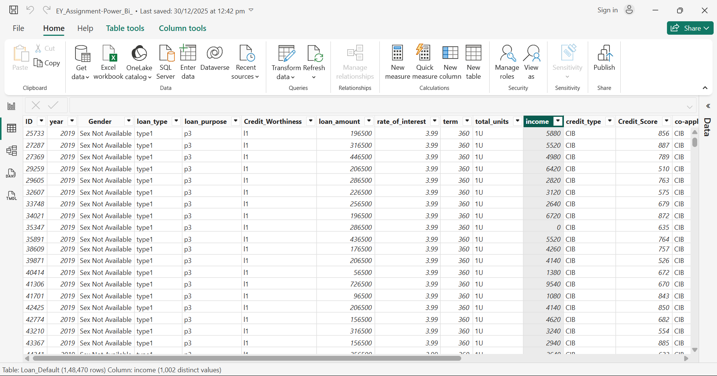

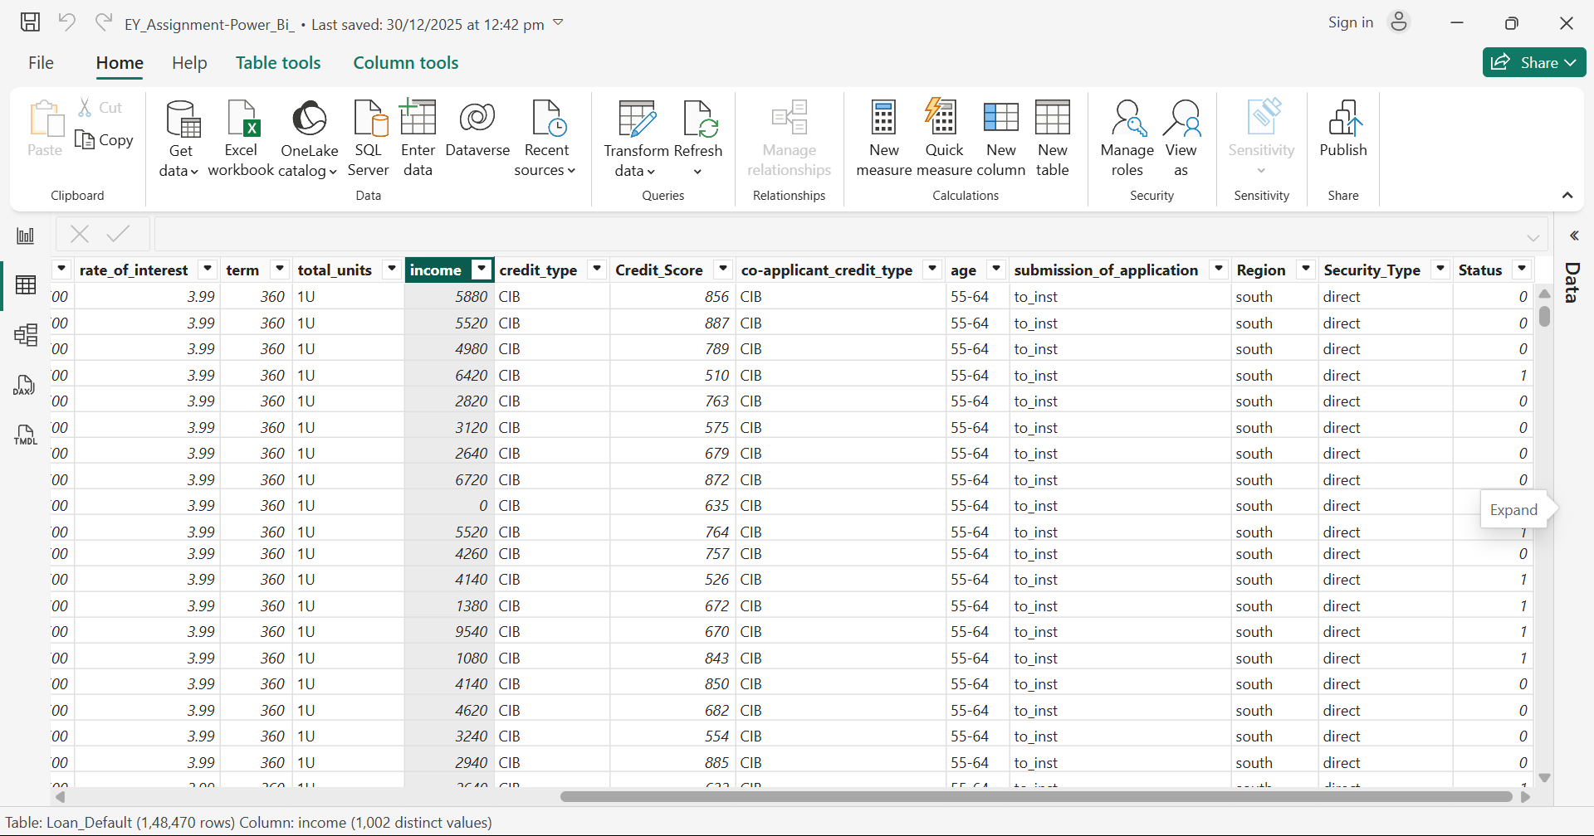

Data Collection
The dataset used in this Power BI project was collected to support the analysis of loan applications and their outcomes. It consists of structured records that capture essential information related to applicants, loan characteristics, and final loan status. Each entry in the dataset represents a single loan application along with its associated details.

The collected data includes key financial attributes such as loan amount, rate of interest, credit score, and applicant income, which are critical for evaluating borrower creditworthiness. In addition, demographic details such as age, gender, and geographic region were gathered to enable comparative analysis across different applicant segments. Information related to loan purpose was also collected to understand how borrowing intent influences loan approval and default behavior.

The dataset further includes the loan status, indicating whether the loan was approved or defaulted. This allows for effective assessment of loan performance and default risk. Overall, the collected data provides a reliable foundation for creating interactive Power BI dashboards that deliver meaningful insights and support informed, data-driven lending decisions.

Data Loading
The dataset was loaded using an Excel file through the Transform process. This ensured accurate import and proper structuring of the data for further analysis.
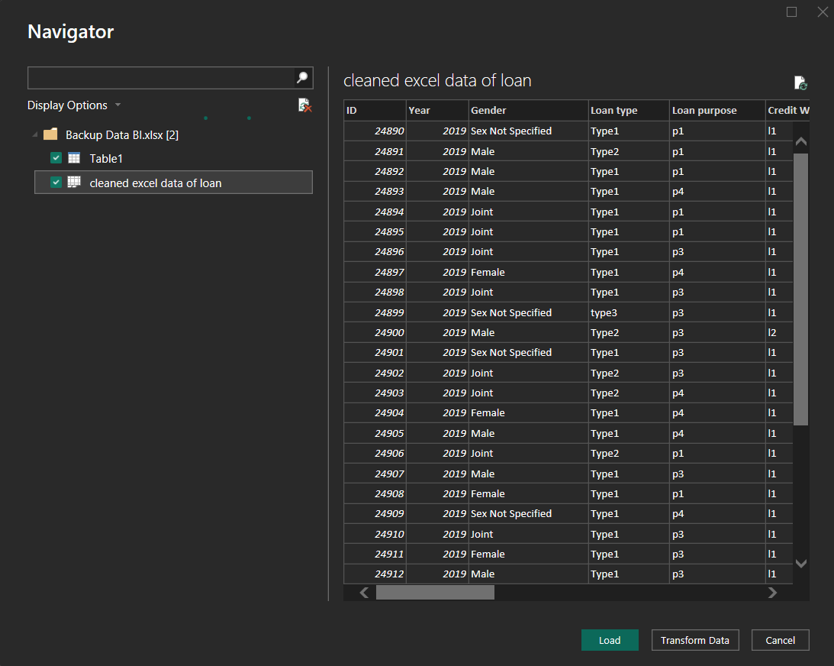

Data Cleaning & Transformation
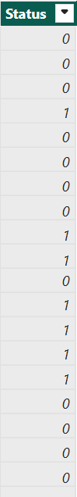
- The dataset was cleaned by standardizing the status column, converting numeric indicators (1 and 0) into categorical values (Approved and Defaulted) to enhance interpretability.

Null values in the rate of interest and income columns were filled using the median, reducing the impact of outliers and improving data reliability.

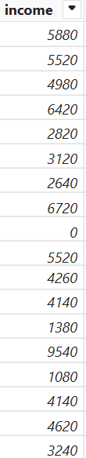
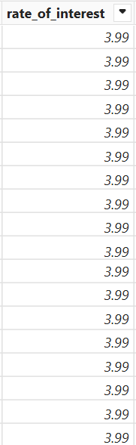

Removal of Irrelevant Columns
- As part of the data cleaning process, unnecessary and non-contributing columns were identified and removed from the dataset.
- Variables such as approv_in_adv, open_credit, business_or_commercial, interest_rate_spread, upfront_charges, term, neg_ammortization, interest_only, lump_sum_payment, along with a few other irrelevant features, were excluded.
- Eliminating these columns helped simplify the dataset, reduce noise, and improve computational efficiency.
- This ensured that the analysis remained focused on the most relevant attributes, leading to clearer insights and more reliable results.

Before
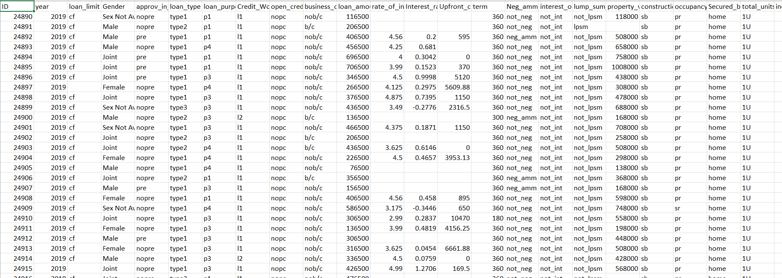

After



Data Modeling
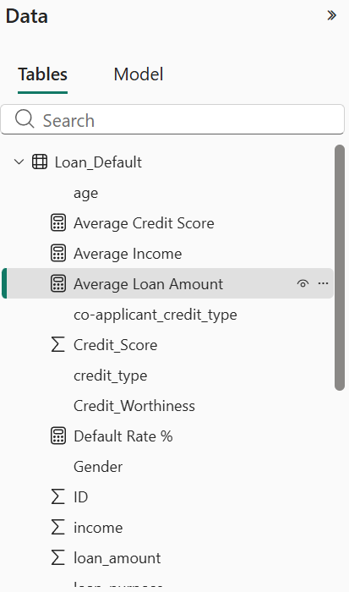
Data modeling is a fundamental step in any data analytics project, as it defines how data is organized, structured, and connected for efficient analysis and visualization. A well-designed data model ensures data accuracy, reduces redundancy, improves performance, and enables meaningful insights by establishing a clear relationship between data elements.

Importance of Normalization

Normalization is a key principle of data modeling that focuses on organizing data into logical structures to minimize duplication and maintain consistency. By separating data into well- defined entities, normalization helps improve data integrity, reduces storage redundancy, and ensures reliable analytical results. It also enhances scalability, making it easier to expand or modify the data model as the dataset grows in size or complexity.

Proper normalization supports efficient querying and ensures that calculations and aggregations are based on clean and consistent data. In analytical tools like Power BI, normalization also improves model clarity and supports better visual interactions across multiple dimensions.

Data Modeling in This Project

In this project, a single consolidated table was used to store all loan-related information for simplicity and ease of visualization. While the physical structure is denormalized for reporting purposes, normalization principles were conceptually applied during data preparation by logically grouping attributes into demographic, financial, and loan-specific categories.

The dataset includes demographic attributes such as age, gender, and region; financial attributes such as income, loan amount, credit score, property value, loan-to-value (LTV) ratio, and rate of interest; and loan-specific attributes including loan purpose, loan type, credit worthiness, and loan status. Each loan record is uniquely identified using an ID field, and a year attribute enables time-based analysis.

Numerical fields were configured to support aggregation and comparative analysis, while categorical fields were modeled as dimensions to enable effective filtering and segmentation across visuals. This modeling approach ensures efficient performance, accurate insights, and a user-friendly analytical experience within the Power BI dashboard.
Overall, the adopted data modeling strategy balances theoretical best practices with practical reporting requirements, making it suitable for analyzing loan approval patterns, creditworthiness, and default risk.

Measures and Calculated Column

Measure:
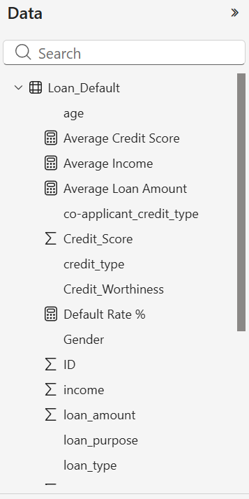
A measure is a calculation used to perform aggregations such as sum, average, count, or percentage. It is evaluated dynamically based on the current filter context in reports or visuals. Measures are not stored in the table and are commonly used to generate KPIs and analytical analysis.

Calculated Column:
A calculated column is a new column created using a formula that operates at the row level within a table. It is calculated during data refresh and stored in the dataset. Calculated columns are mainly used for categorization, segmentation, and creating derived attributes for analysis.

These are the following measures:

Average credit score
- Uses the AVERAGE() DAX function, which ignores blank values for accuracy.
- Dynamically updates based on filters and slicers applied in the report.
- Helps assess overall customer creditworthiness and default risk patterns.

Average Income
- Uses the AVERAGE() DAX function, which excludes blank values automatically.
- Responds dynamically to filters and slicers applied in the Power BI report.
- Supports analysis of income levels in relation to loan approval and default risk.

Average Loan Amount
- This measure calculates the average loan amount from the Power BI Backup table.
- The AVERAGE function computes the mean of the Loan amount column.
- It shows the typical loan size across all filtered records.

Default By Region
- This is a Region slicer used to filter the dashboard data by geographical region.
- Selecting a specific region updates all visuals to show data only for that region.
- Choosing “All” displays data for all regions combined.

Total Approved Loan Measure
- Counts the total number of loans that have Status = "Approved" in the PowerBI Backup table.
- CALCULATE changes the filter context to include only approved loans.
- COUNTROWS then counts how many approved loan records exist.

Total Defaulted Loans Measure
- Counts the total number of loans with Status = "Defaulted" in the Power BI Backup table.
- CALCULATE applies a filter so only defaulted loan records are considered.
- COUNTROWS returns the number of defaulted loans after applying the filter.

Data Visualization

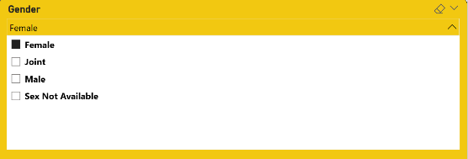
Gender Slicer
- This is a Gender slicer that filters the dashboard based on gender categories.
- Selecting a gender updates all visuals

Loan Purpose Slicer
- This is a Loan Purpose slicer that allows filtering data based on different loan purposes (p1–p4).
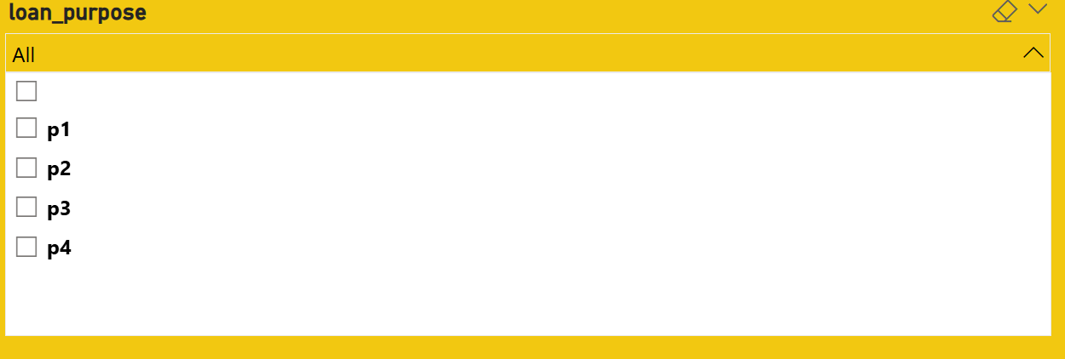
- Selecting one or more options updates all dashboard visuals accordingly.

Region Slicer
- This is a Region slicer used to filter the dashboard data by geographical region. Selecting a specific region updates all visuals to show data only for that region.
- Choosing “All” displays data for all regions combined.
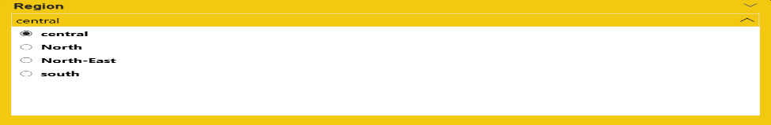

Defaulted Loans by Region (Bar Chart)
- The chart displays the number of defaulted loans across different regions.
- The North region has the highest number of defaults, followed by the South region.
- Central and North-East regions show comparatively fewer defaults, indicating lower default occurrence in these areas.

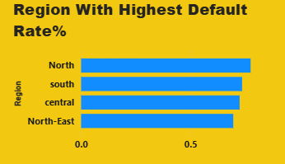

Loan Status Distribution (Pie Chart)
- The pie chart shows the distribution of loans by status: Approved and Defaulted.
- Approved loans form the larger share (112K, ~37.68%), while defaulted loans are fewer (37K, ~12.32%).
- This indicates that most loans in the dataset are approved rather than defaulted.

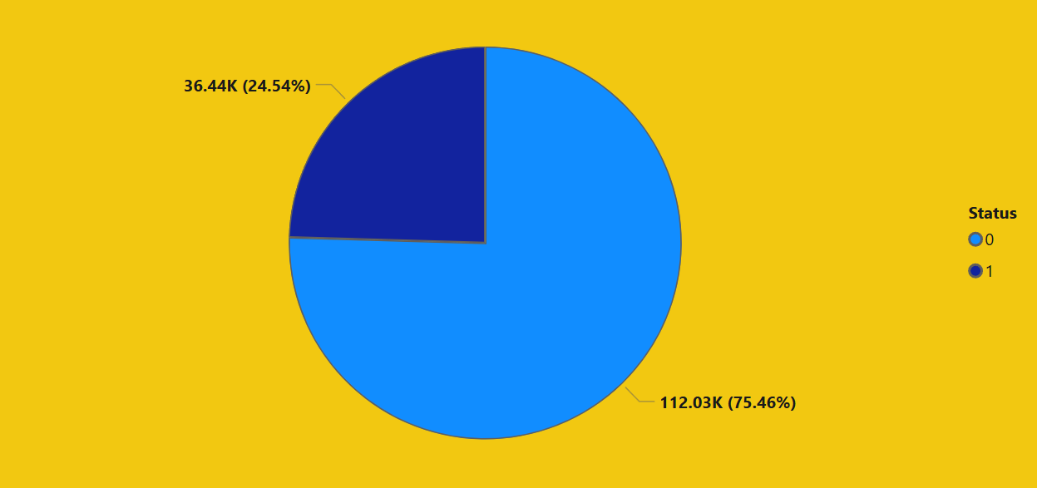

Scatter Plot: Credit Score Affect Loan Approval

- This scatter plot analyses the relationship between a customer’s credit score and loan approval count.
It helps understand how strongly credit score influences loan approval decisions.

- “This scatter plot demonstrates the relationship between credit score and loan approval. It clearly shows that customers with higher credit scores have a greater probability of loan approval.”

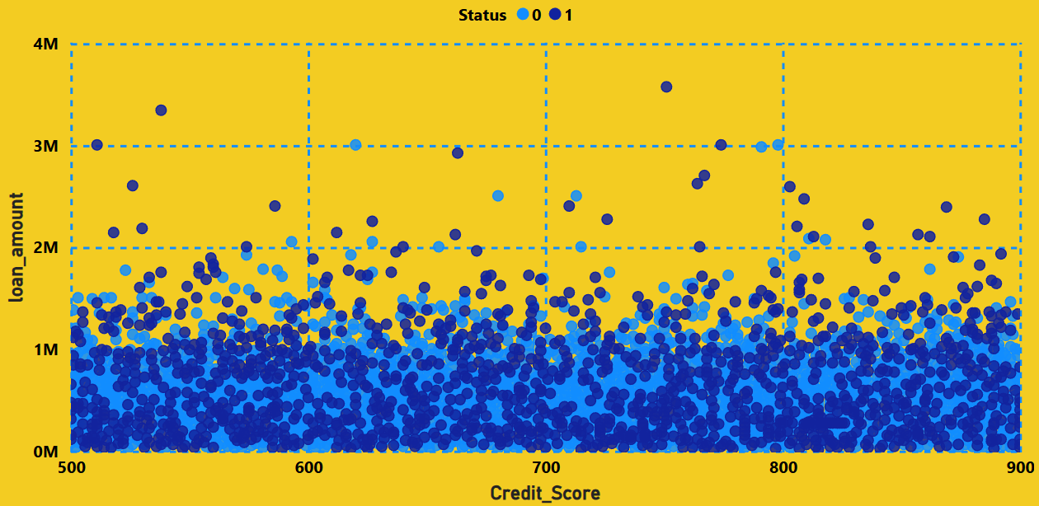

Total Defaulted Loans by Loan Purpose (Treemap)
- The treemap shows the distribution of total defaulted loans across different loan purposes (p1, p2, p3, p4).
- Each block’s size represents the number of defaulted loans for that purpose.
- Loan purpose p4 has the highest number of defaulted loans (42,209), indicating higher default risk compared to other purposes.

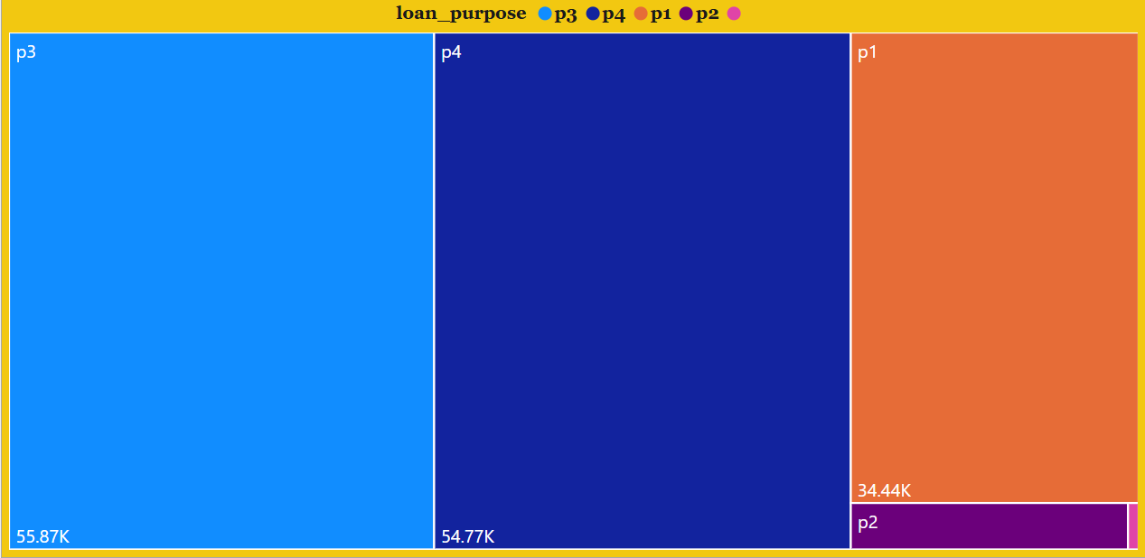

Average Income by Loan Status (Bar Chart)
- The chart compares average income of borrowers based on loan Status (Defaulted vs Approved).
- Borrowers with defaulted loans show a higher average income than those with approved loans.
- This indicates that income alone is not sufficient to predict loan approval or default risk and other factors also influence outcomes.

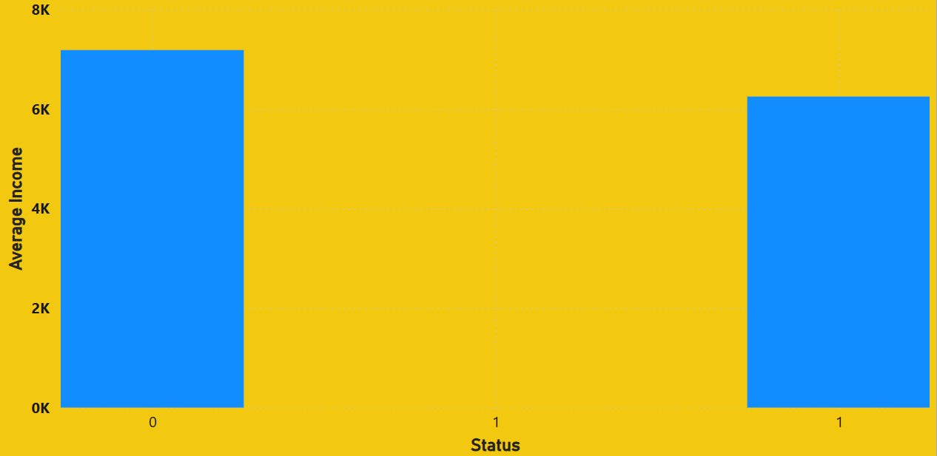

Dashboard
This dashboard presents an interactive analysis of loan performance and credit risk, enabling a clear comparison between approved and defaulted loans. It transforms complex loan data into actionable insights for effective decision-making.

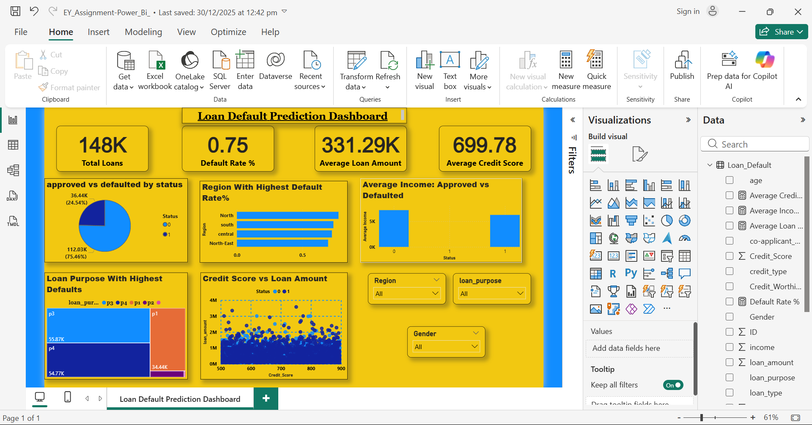

Key Objectives

- Evaluate overall loan portfolio health
- Identify high-risk regions and loan purposes
- Understand borrower behaviour through income, credit score, and loan amount analysis

Key Performance Indicators

- Total Loans Issued
- Total Approved Loans
- Total Defaulted Loans
- Default Rate (%)
- Average Loan Amount

These KPIs offer a quick snapshot of lending efficiency and risk exposure.

Visual Insights
- Loan approval vs default distribution
- Region-wise default concentration
- Loan purpose–based default patterns
- Income comparison by loan status
- Credit score and loan amount relationship across genders

Interactive Analysis
Dynamic slicers for Region, Gender, and Loan Purpose allow users to drill down into specific segments and uncover hidden risk patterns.

Business Impact
The dashboard supports data-driven credit decisions, helps reduce default risk, improves portfolio quality, and strengthens strategic planning for financial institutions.

Insights and Analysis
- Loan Performance Overview
  - The dataset shows a higher proportion of approved loans compared to defaulted loans, indicating overall portfolio stability.
  - However, the presence of a significant number of defaults highlights the need for stronger risk assessment mechanisms.
- Default Risk Patterns
  - Loan Purpose p4 contributes the highest number of defaulted loans, making it a critical risk category that requires deeper scrutiny.
  - Region-wise analysis reveals that the North and South regions experience the highest defaults, while Central and North-East regions show relatively lower risk.

- Income vs Default Behavior
  - Surprisingly, borrowers with defaulted loans have a higher average income than approved borrowers.
  - This insight indicates that income alone is not a reliable indicator of creditworthiness and must be evaluated alongside other factors such as credit score and loan purpose.

- Credit Score and Loan Amount Relationship
  - A positive correlation exists between credit score and loan amount—higher credit scores are associated with larger loan disbursements.
  - Variations across gender categories suggest that credit score-driven policies dominate over demographic bias, which is a healthy lending practice.

- Role of Interactive Filters
  - Slicers for Region, Gender, and Loan Purpose enable dynamic analysis, allowing stakeholders to:
    - Identify high-risk segments
    - Perform targeted regional or demographic assessments
    - Support data-driven decision-making

- Business Implications
  - The analysis clearly shows that credit risk is multidimensional, influenced by loan purpose, region, and credit score rather than a single factor.
  - Financial institutions can use these insights to:
    - Refine approval policies
    - Adjust regional risk strategies
    - Design customized loan products for high-risk purposes

Business Interpretations

- Credit Risk Management
  - Although loan approvals dominate the portfolio, defaults are concentrated in specific segments, indicating scope for targeted risk control rather than blanket tightening of policies.
  - High defaults in Loan Purpose p4 suggest the need for stricter eligibility checks, revised interest pricing, or collateral requirements for this category.

- Income Is Not a Standalone Approval Metric
  - The finding that defaulted borrowers have higher average income implies that relying solely on income can lead to misclassification of risk.
  - Businesses should adopt composite credit scoring models incorporating income, credit score, repayment history, and loan purpose.
- Regional Strategy Optimization
  - Higher defaults in the North and South regions indicate region-specific economic or behavioral factors.
  - Banks can respond by:
    - Implementing region-wise risk premiums
    - Strengthening local credit monitoring teams
    - Running financial literacy or restructuring programs
- Credit Score–Driven Lending
  - The positive relationship between credit score and loan amount validates current lending policies.
  - This supports a business strategy of rewarding financially disciplined customers with higher credit limits, improving portfolio quality.

- Gender-Neutral Lending Insights
  - Loan disbursement trends across genders largely follow credit score behavior, suggesting minimal demographic bias.
  - This enhances regulatory compliance, brand trust, and ESG alignment.

- Portfolio Optimization & Profitability
  - Identifying high-default segments enables:

    - Better capital allocation
    - Lower Non-Performing Assets (NPAs)
    - Improved risk-adjusted returns

- Decision Support Value
  - The interactive dashboard allows management to perform what-if analysis using slicers.
  - This supports faster, data-backed decisions in credit approval, policy revision, and strategic planning.

Conclusion
This project presents a comprehensive and insightful analysis of loan data using Power BI and business analytics techniques, transforming raw financial records into a clear, interactive, and decision-oriented dashboard. The analysis reveals that although loan approvals dominate the portfolio, default risks are not evenly distributed and are primarily concentrated across specific loan purposes and regions.

The study highlights a critical business insight: income alone does not determine creditworthiness. Instead, default behavior is shaped by a combination of factors such as credit score, loan purpose, and regional patterns. The strong relationship between credit score and loan amount validates structured lending policies, while regional and purpose-based defaults signal areas where tighter controls and strategic interventions are required.

By integrating well-defined DAX measures with intuitive visualizations and slicers, this project enables stakeholders to identify risk patterns, optimize lending strategies, and support data- driven decisions. Overall, the project reinforces the role of business analytics as a strategic tool in enhancing credit risk management, improving portfolio quality, and ensuring sustainable growth for financial institutions.

Limitations
  - The analysis is based only on the available historical dataset; any missing, inaccurate, or outdated data may affect the reliability of insights.
  - Important credit risk factors such as repayment history, interest rates, collateral details, and macro-economic conditions are not included, limiting deeper risk assessment.
  - The project focuses on descriptive and diagnostic analysis; it does not use predictive models to forecast future defaults.
  - Results are time-bound and may change with market conditions, borrower behavior, or policy revisions.
  - The insights depend on data granularity; aggregated visuals may hide individual-level risk patterns.

These limitations indicate scope for further enhancement using richer data and advanced analytics techniques.

Future Scope
The Loan Analytics Dashboard has strong potential for further enhancement and real-world application. In the future, this project can be expanded in the following ways:

Predictive Analytics Integration:
Machine learning models can be incorporated to predict loan defaults, enabling proactive risk management instead of descriptive analysis alone.

Inclusion of Additional Variables:
Adding factors such as repayment history, interest rates, loan tenure, collateral details, and macro-economic indicators would provide deeper and more accurate risk assessment.

Time-Series and Trend Analysis:
Analyzing loan performance over time can help identify seasonal patterns, economic impact, and early warning signals of rising default risk.

Advanced Segmentation:
Customer segmentation based on behavior and risk profiles can support personalized loan products and targeted credit policies.

Real-Time Dashboard Deployment:
Connecting the dashboard to live databases would allow real-time monitoring of loan performance and faster managerial decisions.

Integration with Banking Systems:
The dashboard can be embedded into core banking or CRM systems to support automated decision-making and compliance reporting.

